Vienna Declaration for a GMO-free Europe
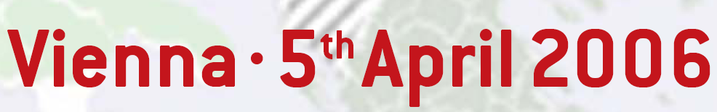
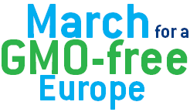

By virtue of the democratic rights of citizens, and conscious of the cultural diversity of Europe we demand the right of self-determination for the European regions and countries to ensure a GMO-free environment and GMO-free food.

Transgenic agriculture will have serious impacts on the survival of conventional and organic agriculture in Europe. Without clear laws on genetic pollution, the quality of our agriculture cannot be guaranteed. We now face the challenge of protecting our natural and agricultural biodiversity.

We strongly support the European network of GMO-free regions and countries that promote GMO-free food and farming. We call on the institutions of the European Union and on national governments and parliaments to allow a GMO-free Europe, and to establish, by end 2007, the legal basis for the following demands of the citizens of Europe:
- Guarantee the comprehensive right for European consumers to GMO-free food and the right for farmers to GMO-free agriculture. The right to choose what we eat includes the right to food without any GMO-contamination.
- The EU must allow further development of GMO-free regions and acknowledge the right of self-determination on GMOs.
- The European Food Safety Authority (EFSA) must be reformed and a truly independent GMO-risk assessment established. GMO approval procedure in the EU must be based on the precautionary principle as enshrined in the EU and international law like the Protocol on Biosafety.
- GMO-free agriculture must take priority over a new and risky production with GMOs. Technical standards must be specified to allow GMO-free production both in organic and conventional farming.
- The production of GMO-free seeds should be regulated to prevent any possible risk of genetic pollution. The currently applicable Austrian standard (the Austrian purity requirements for seeds), which has also been supported by the European Parliament, should become an EU standard. GMO-free areas for growing seeds should be established.
- The GMO-polluters - both GMO-users and biotech companies holding GMO-consents - must be held responsible and liable for all damages caused by the GMO and the GMO-contamination.
- The interim ruling by the WTO on the GMO dispute, as well as other studies and reports on GMOs commissioned by the European Commission, have to be made public. The European Commission must appeal to any final ruling by the WTO that impinges on our right to GMO-free agriculture and to a GMO-free food supply, involving impartial scientists in the preparations of the appeal.

These demands are based on the following necessities and facts:

The right to food free from genetic modification
All of us have the right to choose food without genetically modified organisms (GMO). Decisions about the use of reproductive material in a common environment cannot be made individually, as they affect all of us, because the living environment belongs to each and everyone. Decisions concerning the use of GMO and the structuring of agriculture in countries and regions should not be imposed by particular farmers, bureaucrats or companies. The use of GMOs in nature is irreversible.

Protection and Precaution
The consumption of genetically modified food by millions of people is like a large and uncontrolled experiment, which could have unexpected consequences. Concerns about new allergens, antibiotic resistance, pesticide exposure etc. are being raised by medical experts. We strongly condemn the use of people and animals throughout the world as guinea-pigs for GMOs in food..

Coexistence is impossible
Coexistence between genetically modified and GMO-free farming in European agriculture is not possible, just like there is no coexistence between silence and noise in a room. Local plants and their wild relatives require the highest standards of protection. The protection of conventional and organic varieties must be given a higher priority than the introduction of GMOs. Coexistence must not be facilitated by allowing routine GMO contamination – “a bit” GM-free is not acceptable.
Technical standards must be specified to allow GMO-free production in organic and conventional farming. The GMO-users as well as the biotech companies holding GMO consents must be held responsible and liable for all damage caused.
“High risk” genetically modified crops with a high potential of gene-transfer, such as oilseed rape, must in no way be approved for growing because of the irreversible nature their pollution.

Purity requirements for seeds
Seeds are positioned at the beginning of the food chain. Without GMO-free seeds there cannot be GMO-free farming and no GMO-free food. Furthermore, alternative farming systems such as organic farming are endangered by GMO-contaminated seeds. Therefore no contamination of seeds by GMOs can be allowed (such as in the Austrian purity law). The rigorous Austrian law for GMO-free seeds should become an EU-standard.
Local seed diversity, traditional plant varieties and their wild relatives provide respective regions with their character, taste and heritage. This allows diversity to develop and increase including that of GMO-free seeds. Regional farming policy must include the right to protect traditional and locally adapted plant varieties, the right to GMO-free farming and the conservation and use of traditional seeds.
There is a real risk that genetic contamination will cause widespread and irreversible damage to traditional plant varieties and seed lines, causing great loss to our biodiversity and cultural heritage.

Independent risk research and a transparent approval procedure
Biotech research and risk assessment must not be left in the hands of the biotech industry. Thorough and truly independent risk assessment is needed, and the approval process for GMOs must include public participation due to the potentially far-reaching consequences of the technology. Transparency and independence are crucial.

Our food sovereignty and labelling
The overwhelming majority of Europeans do not want genetically modified food. Responding to the demand for GMO-free food and farming is an essential part of a Region’s food sovereignty and economic development. Regional authorities must be able to protect quality labels, purity standards, organic products, and designations of origin in a competitive manner. This includes in particular the access to GMO-free seeds as well as to GMO-free animal feed.

Sustaining Agricultural Biodiversity
Farming is an integral part of our regional way of life. The socio-economic and cultural impacts must be considered when introducing transgenic agriculture. The vast majority of European countries wish to promote sustainable and organic farming and regional marketing for their rural development. The right of self determination of regions and countries and the right to farm without GMOs must be legally safeguarded by the EU.

